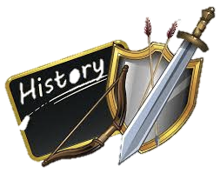
Monday 11th January
L.O: To learn about Mary Anning
I know how to respond to historically valid questions about a significant historical figure and suggest or plan ways to answer them

Read your information sheet and answer the following questions
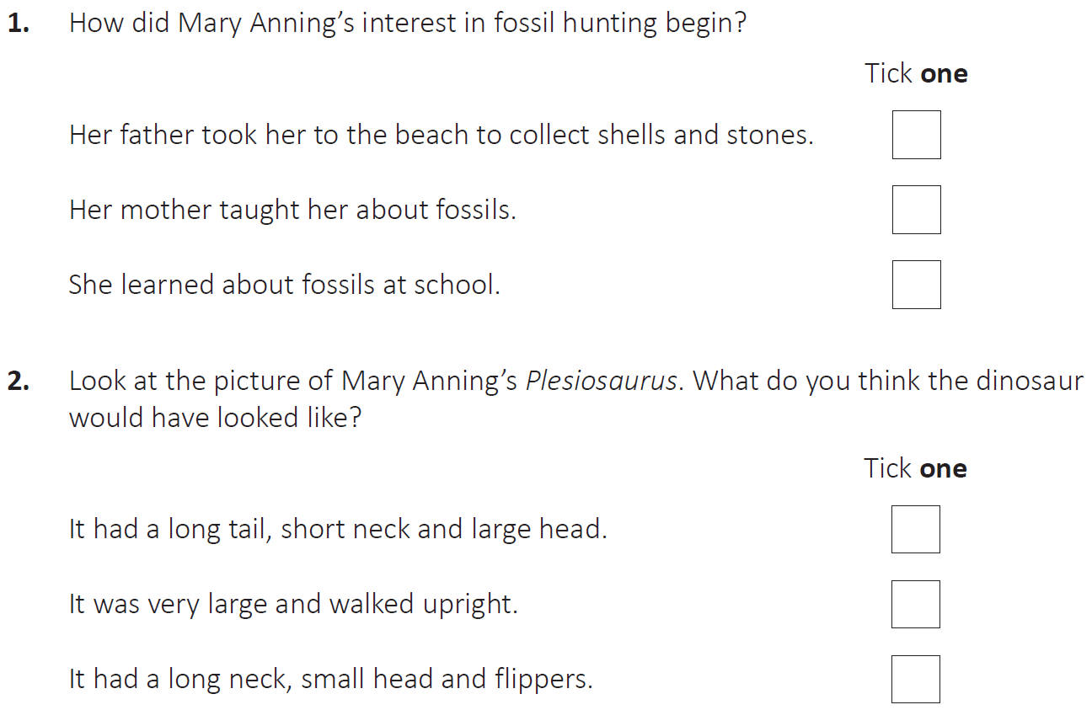

Now, find 3 interesting facts about Mary Anning

