
Wednesday 13th January
L.O: To describe the parts of a volcano or earthquake
K.O check: Who was Mary Anning?

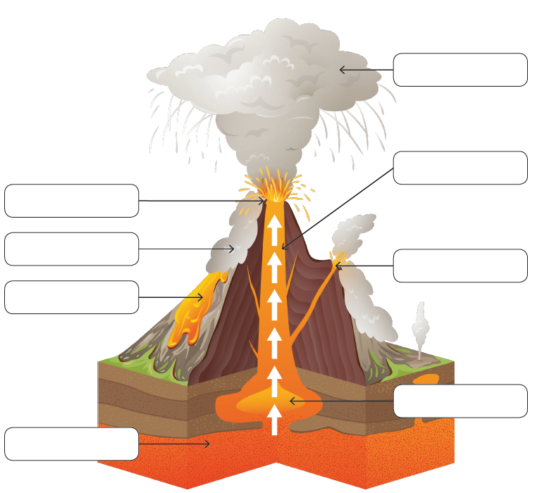

Use these words to help you: ash cloud, crater, lava, magma chamber, vent, throat, mantle, pyroclastic flow
What are the three types of volcanic status and what do they mean?

