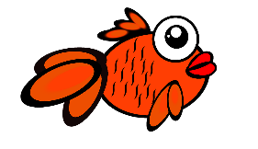
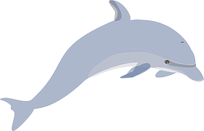
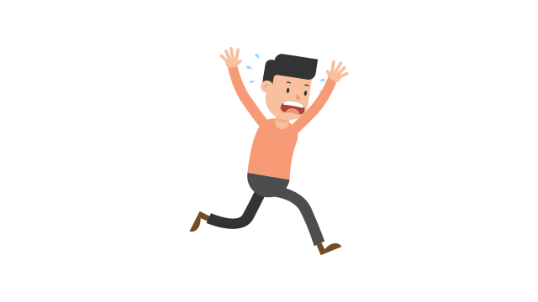

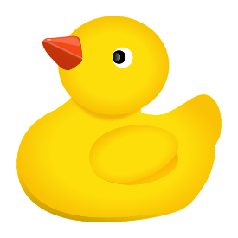
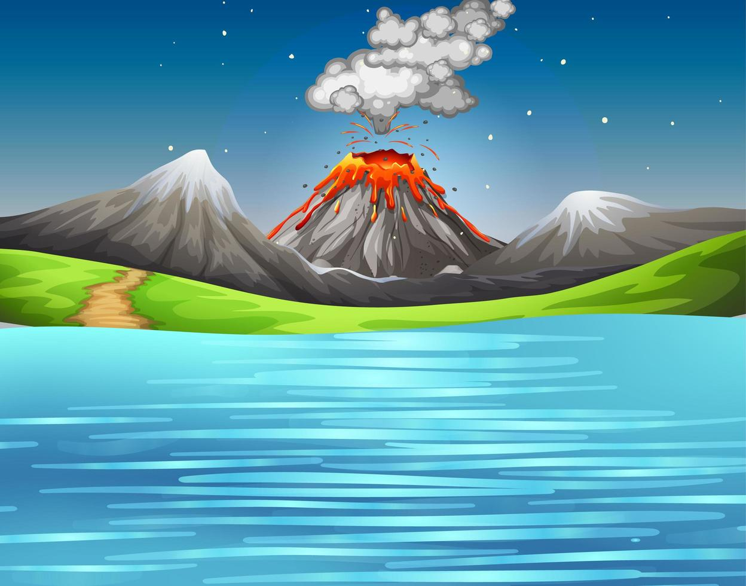

Help, I’m struggling to see

Quick, RUUUUUUUUN!

Avoid Earth, it’s smoky down there!

I’m going to swim the other way!

What is going on up here?

This Photo by Unknown Author is licensed under CC BY-SA

