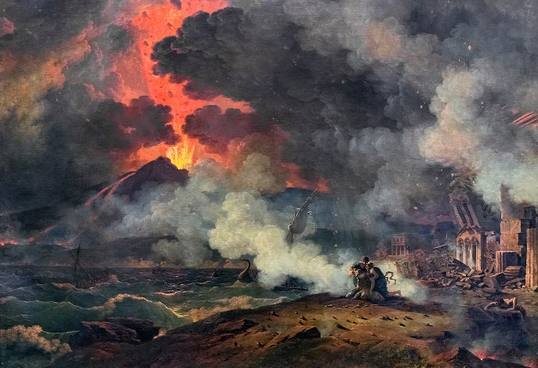
Pompeii after the eruption – Senses map
See
_______________________________________________________________________________________________________________________________________________________________________________________________________________________________________________________________________________________________________________________________________________________________________________________________________________


Hear
_______________________________________________________________________________________________________________________________________________________________________________________________________________________________________________________________________________________________________________________________________________________________________________________________________________
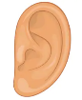

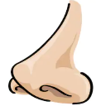
Smell
_______________________________________________________________________________________________________________________________________________________________________________________________________________________________________________________________________________________________________________________________________________________________________________________________________________

Feel
_______________________________________________________________________________________________________________________________________________________________________________________________________________________________________________________________________________________________________________________________________________________________________________________________________________

