
EDITING STATION 1: PUNCTUATION PARTY!
HAVE A LOOK FOR –
- CAPITAL LETTERS (START OF SENTENCES AND PROPER NOUNS)
- FULL STOPS TO FINISH SENTENCES
- QUESTION MARKS OR EXCLAMATION MARKS IF NEEDED
- COMMAS – IN A LIST OR TO SEPARATE CLAUSES
- BRACKETS TO ADD EXTRA INFORMATION

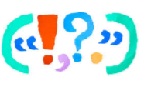
CHALLENGE – SEMI-COLON IF YOU KNOW HOW IT WORKS!
EDITING STATION 2: ADVERBIAL PHRASES
HAVE A LOOK FOR –
- ADVERBS IN YOUR SENTENCES (HINT: LY WORDS)
- PHRASES THAT TELL THE READER – WHAT/WHEN/WHERE/HOW/WHY
- PREPOSITIONAL PHRASES – UNDER/ABOVE/BETWEEN

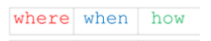
CHALLENGE – CAN YOU SWITCH YOUR SENTENCE STRUCTURE AROUND TO START WITH A FRONTED ADVERBIAL?
EDITING STATION 3: DETERMINERS
HAVE A LOOK FOR –
- LOTS OF SENTENCES STARTING WITH ARTICLES: THE, A OR AN. If you have lots of these try:
- SWITCHING YOUR SENTENCE STRUCTURE SO THAT YOUR OPENERS ARE VARIED



EDITING STATION 4: SPELLING
HAVE A LOOK FOR –
- SPELLINGS THAT DON’T LOOK RIGHT
- DICTIONARIES
- THE YEAR 3/4 SPELLING WORDS LIST


CHALLENGE – CAN YOU FIND ALL YOUR MISSPELLED WORDS?

EDITING STATION 5: NEWSPAPER FEATURES

HAVE A LOOK FOR –
- A HEADLINE
- A BYLINE
- AN INTRODUCTION WHICH ANSWERS THE 5 Ws
- REPORTED OR DIRECT SPEECH (QUOTES)
- PARAGRAPHS
- CHRONOLOGICAL ORDER
- A PICTURE WITH A CAPTION

EDITING STATION 6: THESAURUS PARTY!
HAVE A LOOK FOR –
- DULL ADJECTIVES
- BORING VERBS
- ALTERNATIVES IN THE THESAURUS
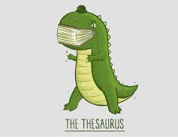
CHALLENGE – CAN YOU UPLEVEL YOUR CONJUNCTIONS?

