
Wednesday 27th January
LO: To create a timeline of the events in the story ‘Escape from Pompeii’ by Christina Balit.
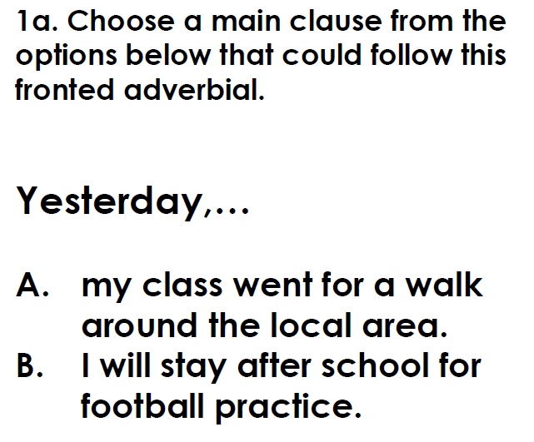
I know how to identify the main ideas from a text.
SPaG Starter
Write notes about the story of Escape from Pompeii, breaking the story down into three sections. You only need to write notes (words and short phrases) so that you know what is happening and Tranio’s feelings at different points of the day.

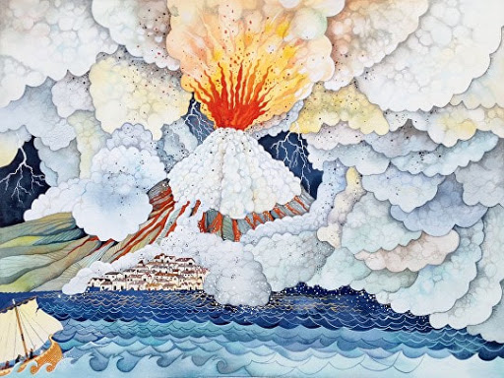
Just in time! (5 minutes 47 secs on video to 6 minutes 53 secs)
________________________________________________________________________________________________________________________________________________________________________________________________________________________________________________________________________________________________________________________________________________________________________________________________________________________________________________________________
Running to escape (4 minutes 5 secs on video to 5 minutes 46 secs)
________________________________________________________________________________________________________________________________________________________________________________________________________________________________________________________________________________________________________________________________________________________________________________________________________________________________________________________________
At the beginning of the day (2 minutes 15 secs on video to 4 minutes 4 secs)
__________________________________________________________________________________________________________________________________________________________________________________________________________________________________________________________________________________________________________________________________________________________________________________________________________________________________________________________________________________________________________________________

