My fabulous potion advert plan
Product name:
________________________________________________________
Logo (including colours I might use):

An introductory sentence or two which tells us how amazing the product is:
______________________________________________________________________________________________________________________________________________________________________________________________

Slogan:
________________________________________________________

Rhetorical questions:
________________________________________________________________________________________________________________________________________________________________________________________________________________________________

Adjectives to make your potion sound AMAZING:
________________________________________________________________________________________________________________________________________________________

Special offers:
________________________________________________________________________________________________________________________________________________________________________________________________________________________________

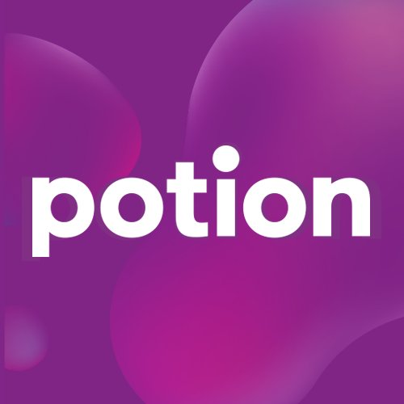
Wonderful words! Try to think of some alliteration, rhyme, exciting adverbs…
________________________________________________________________________________________________________________________________________________________________________________________________________________________________
A sentence including exaggeration:
_____________________________________________________________________________________________________________________________________________________________________________________________________________________________________

