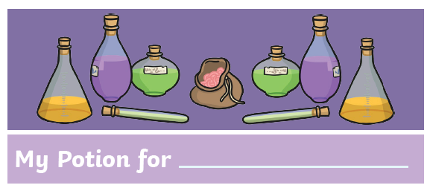
You have learned lots with Professor Snape in his Potions classes, and now you are creating your own Potion to sell to people. Use this sheet to write notes about your incredible new Potion.
How is the potion special and how will it make people feel if they take it?
________________________________________________________________________________________________________________________________________________________________
Who do you think would buy your potion?
________________________________________________________________________________________________________________________________________________________________
What will it look like?
Exciting words to describe how great your potion is:

Ingredients – make them sound impressive!
________________________________________________________________________________________________________________________________________________________________
What is your potion for and why do we need it?
__________________________________________________________________________________________________________________________________________________________________________________________

