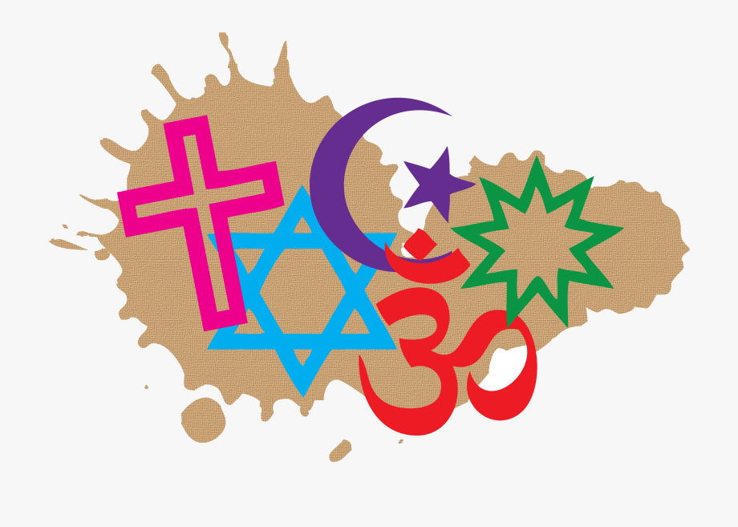
Monday 11th January 2021
R.E
Learning objective: To make a New Year’s resolution.
I know: how to ask and respond to questions about what individuals and communities do and identify what difference belonging to a community can make.



