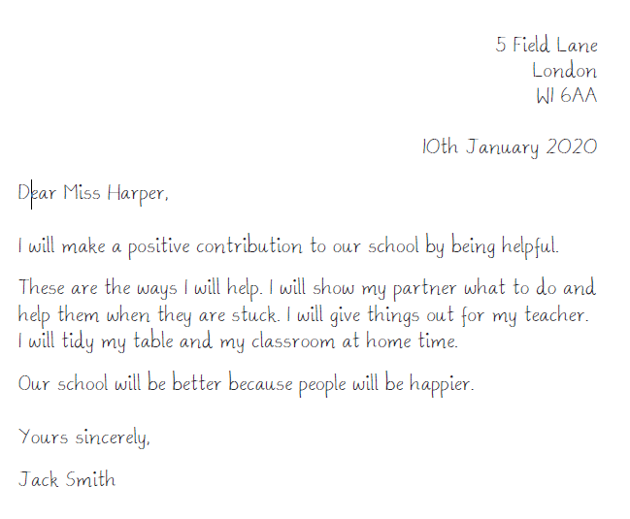
Signing off:
For letters you tend to sign them off with your name, so that the person knows who to reply to.
Finish: If you know the person, but not too well and the letter is of importance, then you use ‘Yours sincerely’. If you do not know the person at all you would use ‘Yours Faithfully’.
Final statement: Usually just one sentence like the opening statement, which just tells the reader why your letter is so important.
Main part of the text. This where you go into detail about what it is you are going to do.
Opening statement: Usually just one sentence which tells the reader what the letter is about.
Address
Begins letter with ‘Dear’ and then Mrs, Miss or Mr followed by the person’s surname.
Date

