Musician of the Month: January 2021
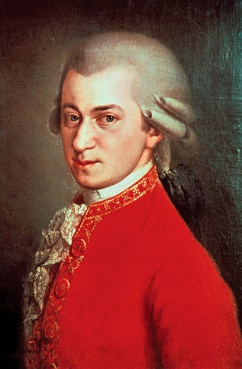
Wolfgang Amadeus Mozart
(1756-1791)

Music of the Week
Week beginning
Monday 4th January

‘Rondo Alla Turca’
by Wolfgang Amadeus Mozart


