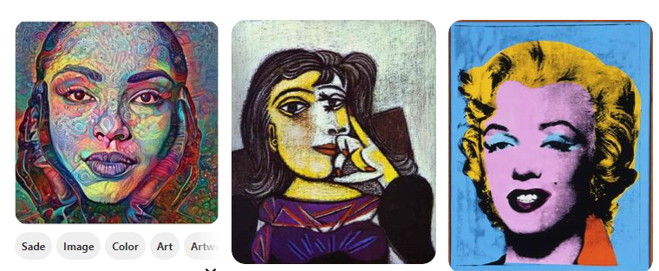
Portrait of Dora Maar Blue Marilyn by by Pablo Picasso Andy Warhol
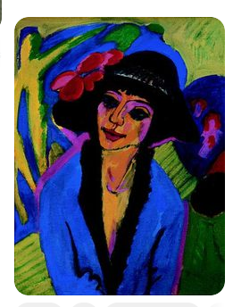
Portrait of Gerda by
Ernst Ludwig Kirchner.


Self-Portrait as a Tehuana
and My Grandparents, My
Parents and Me
by Frida Kahlo

