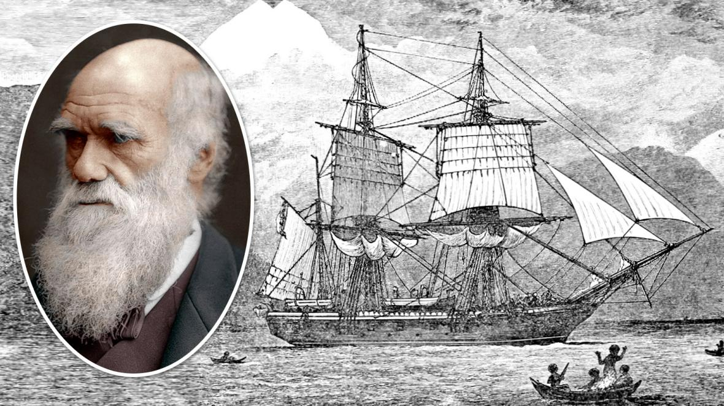
Week 1
English- Labelling and Journals.
Memorable Experience- Observing and comparing features and characteristics of different species.
History – Charles Darwin.
Geography- Using maps to plot the course of the HMS Beagle.

Week 2
English- Diaries.
Science– Animals, plants and adaptation.
Science- Working Scientifically Investigation- How are bird’s beaks adapted to eat specific food?

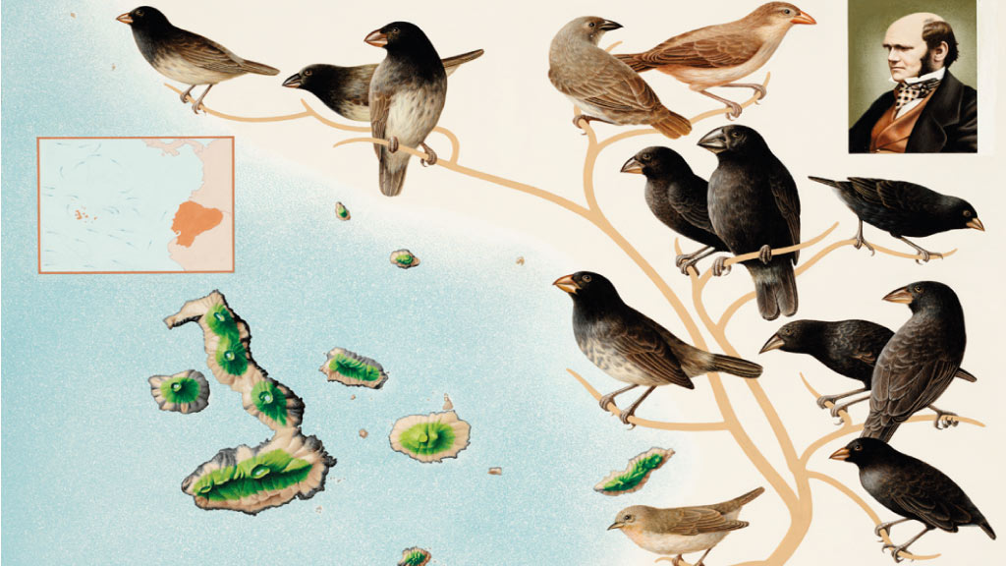

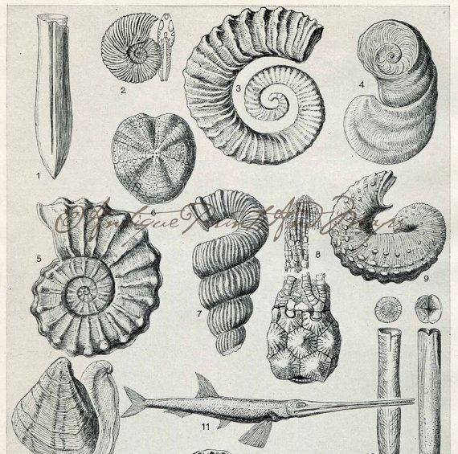
Week 3
English- Letters.
History – Mary Anning, fossil collector and palaeontologist.
Art – Create detailed sketches of shells.

Week 4
English- Explanations.
Science – Working Scientifically to extract strawberry DNA.
Science– Gregor Mendel- theory of inheritance.
Science– Researching Natural and Artificial Selection.



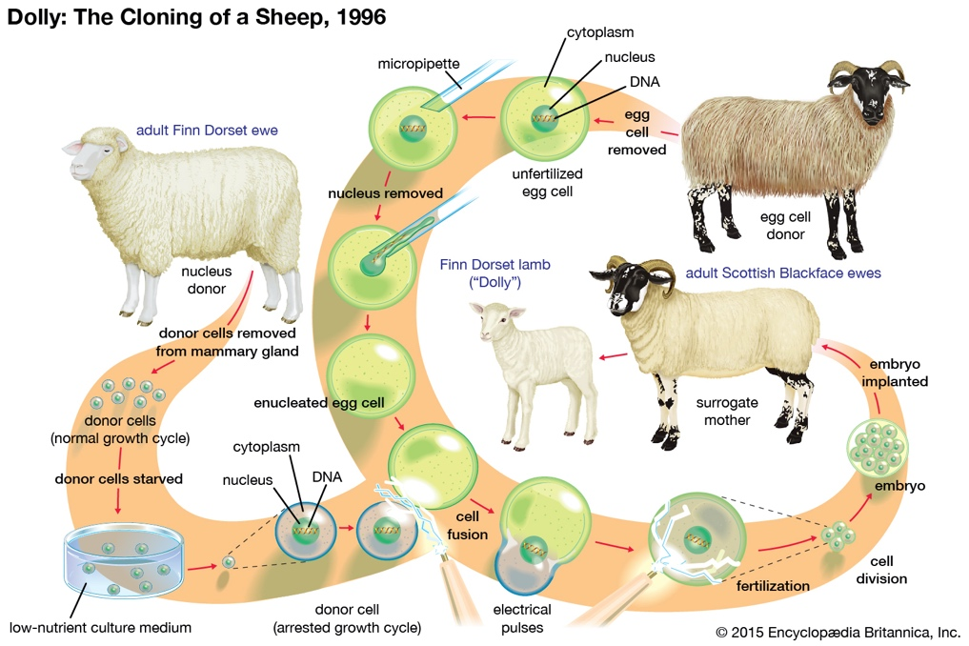
Week 5
English- Newspapers.
Science – Debate- Genetic cloning, artificial selection, genetic engineering.
Innovate- Future Humans.
Art-Sketching future human evolution.
Computing- Morphing Software.

Week 6
English- Newspapers.
Innovate- Future Humans.
Science- Using project knowledge to create a scientific quiz.
Presentation to summarise learning.



