
Wednesday 20th January 2021
LO: To describe a significant historical event in British history. I know significant historical events include those that cause great change for large numbers of people.

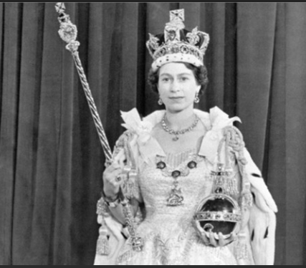
The Queen’s Coronation Report
The Queen’s Coronation was in what year?
____________________________

I heard….
____________________________________________________________________________________________________________________________________________________________

I felt….
______________________________________________________________________________________________________________________________________________________________
I saw…..
__________________________________________________________________________________________________________________________________________________________

