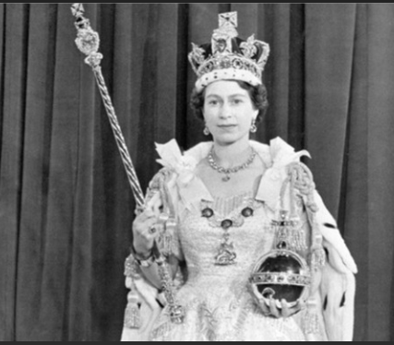
The Queen’s Coronation Report
I heard….
I heard people cheering and singing.
I heard the horses trotting.
I heard clapping and shouting.

I felt….
I felt happy and excited.
I felt the sun on my face.
I felt the wind blowing.
I saw…..
I saw lots of happy people.
I saw some horses pulling a carriage.
I saw soldiers on horses.
I saw the Queen.

