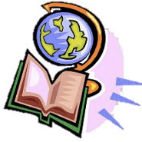
Thursday 25th February 2020
LO: To draw or read a simple picture map.
I know a map is a picture or drawing of an area of land or sea that can show human and physical features. A key is used to show features on a map. A map has symbols to show where things are located.

Key

