Payment Method | I would use this to buy
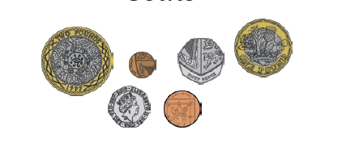
Coins

Bank Notes
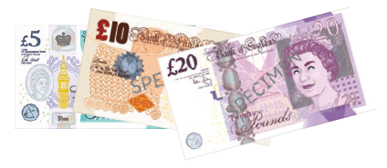

Bank Card
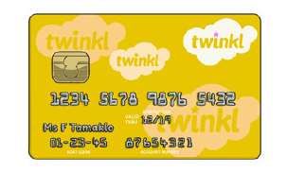

Contactless Payment
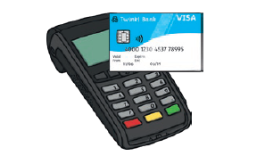

Online Money Transfer
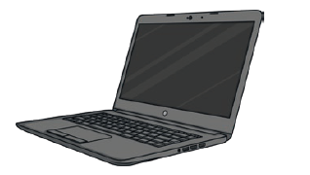

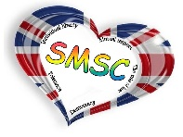
LO: To know what money is and that money comes in different forms.
I know: that money comes in coins, bank notes and other forms and why people need money

