Find and write the ‘oy’ words.
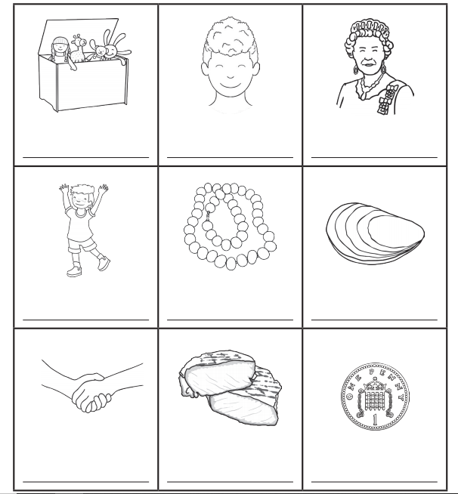
Write the words and then colour the pictures with an ‘oy’ sound in them.

