
Monday 1st March 2021
LO To understand costumes and special clothes play an important part in Purim celebrations
Success criteria:
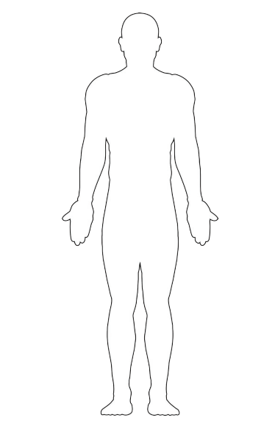
To design a special outfit for a celebration

Monday 1st March 2021
LO To understand costumes and special clothes play an important part in Purim celebrations
Success criteria:
To design a special outfit for a celebration



