Can you match the sentence to the picture?
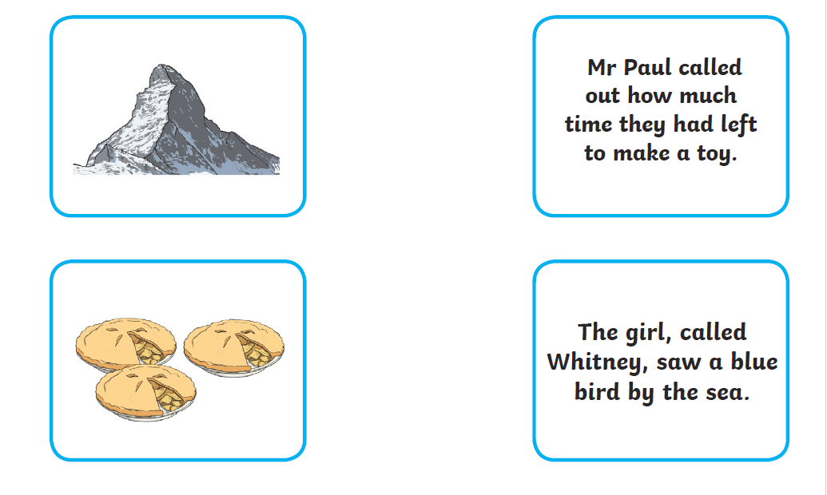
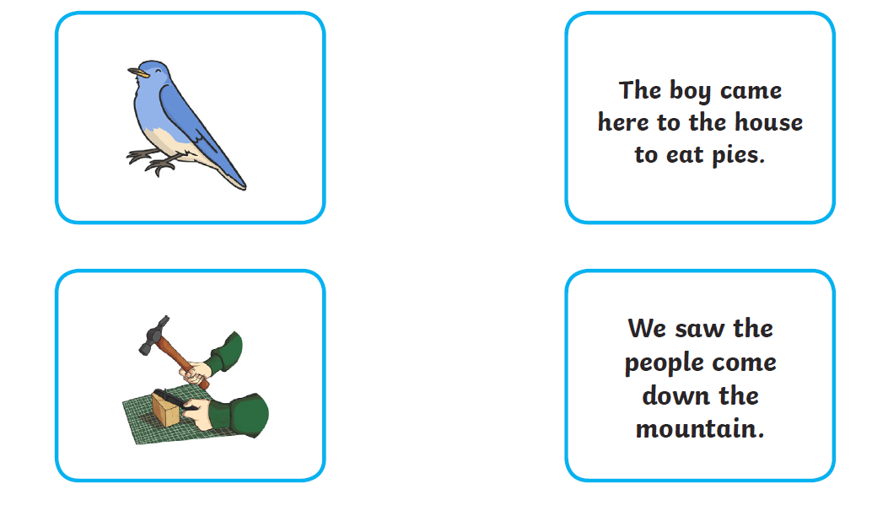
If you cannot print, write the sentence in your book and draw a picture to match.

