Find and Write the ‘ou’ Words
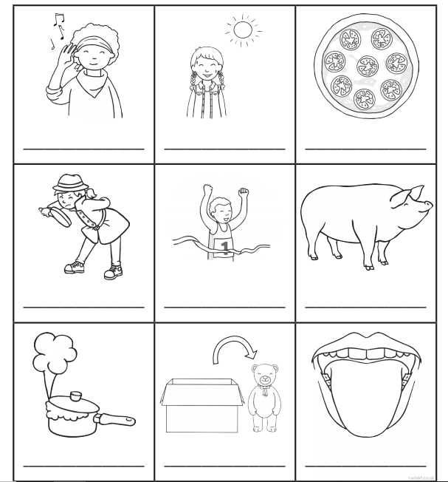
Write the words and then colour the pictures with an ‘ou’ sound in them.

