Colour by Phonics
Phase 5 Real and Nonsense 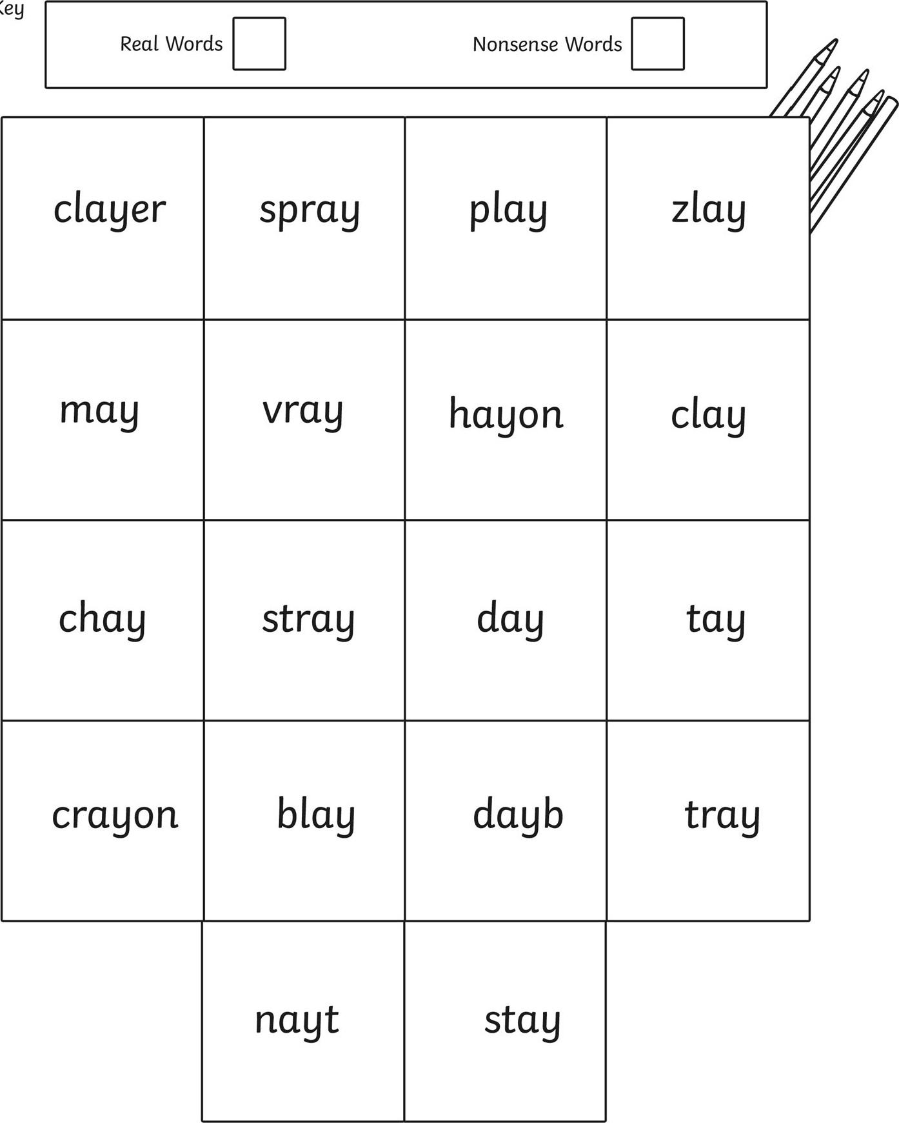

Fill in your key with a different colour for real words and nonsense words then colour in the correct box

