
L.O. To understand how medicines can help people stay healthy and that some people need to take medicines every day.
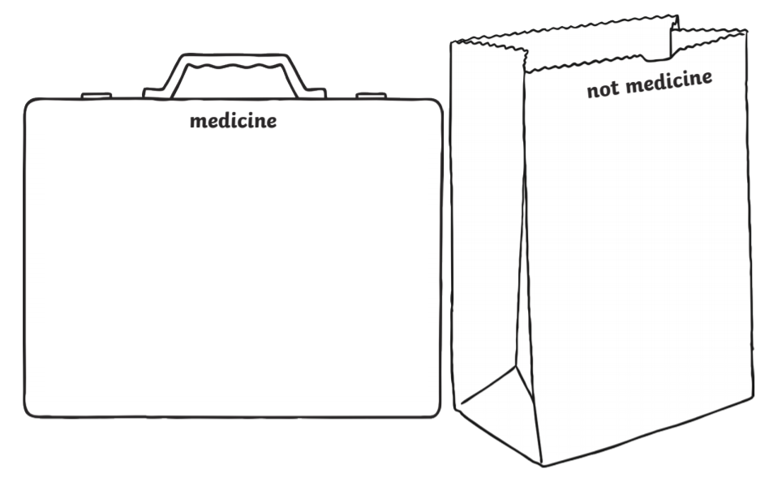
I know: that medicines can be harmful if not used properly.



