William’s family
 |  |  |  |  |  |  |  |  |  | 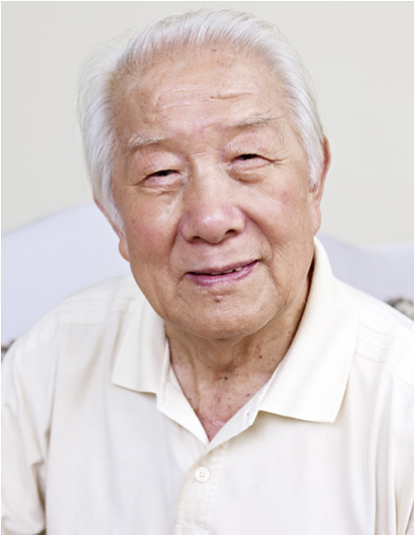  Grandad Shen
  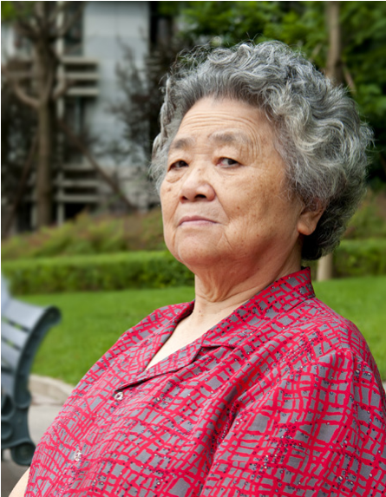 |  | 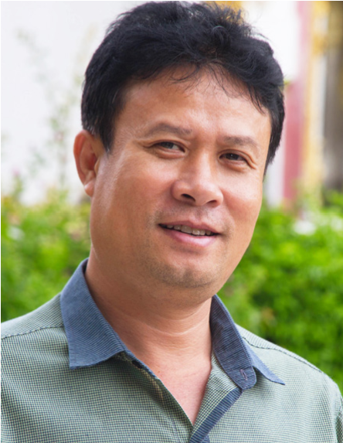 |  | 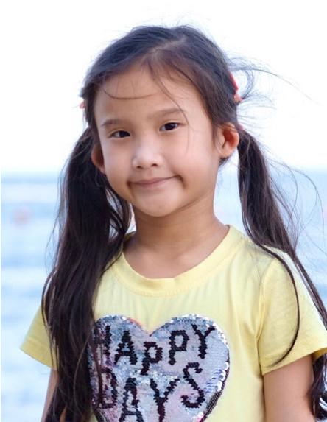
  Grandma Mei |  | Dad |  | Sophie
 |  |  |  | 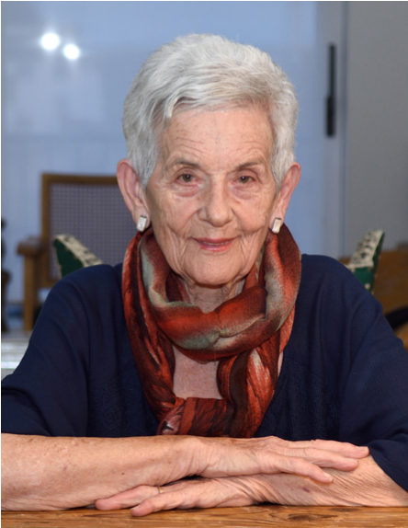 |  |  | 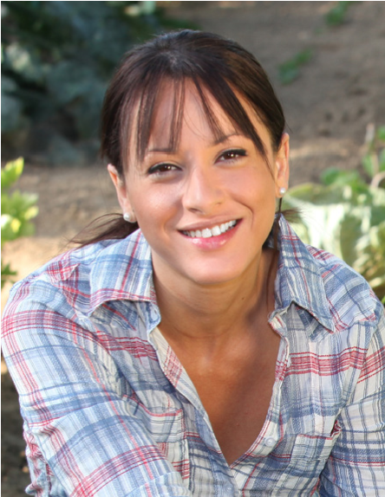 |  |  |  | 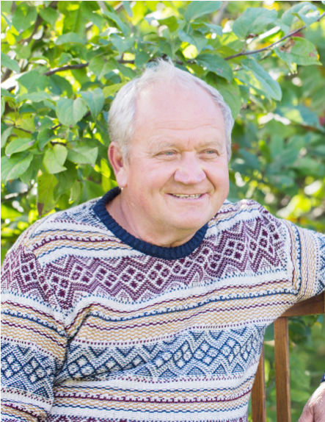
 | Aunty Jane |  |  | Granny Eileen |  |  | Mum |  |  |  | Grandad Joe
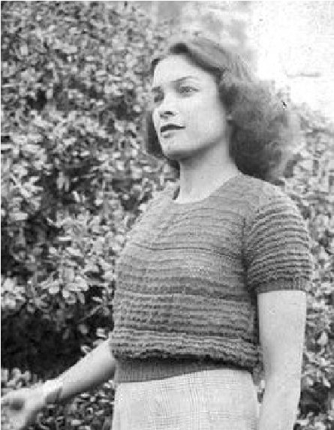  Great Grandma  Connie |  |  |  |  |  | 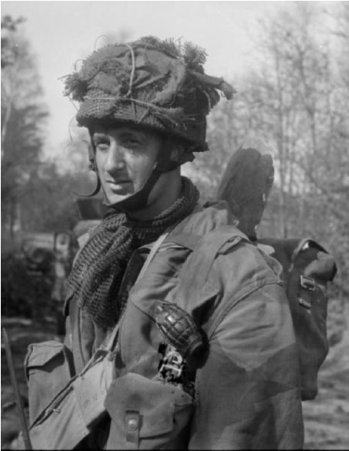  Great Grandad  Peter
  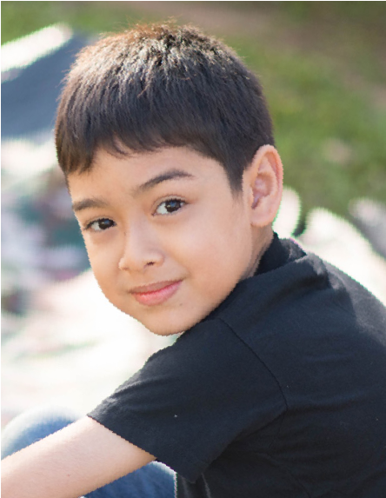
  William

