
Wednesday 3rd February
L.O: to understand the properties of rocks and why this makes them good for use
I know and can Compare rocks based on their appearance, properties or uses
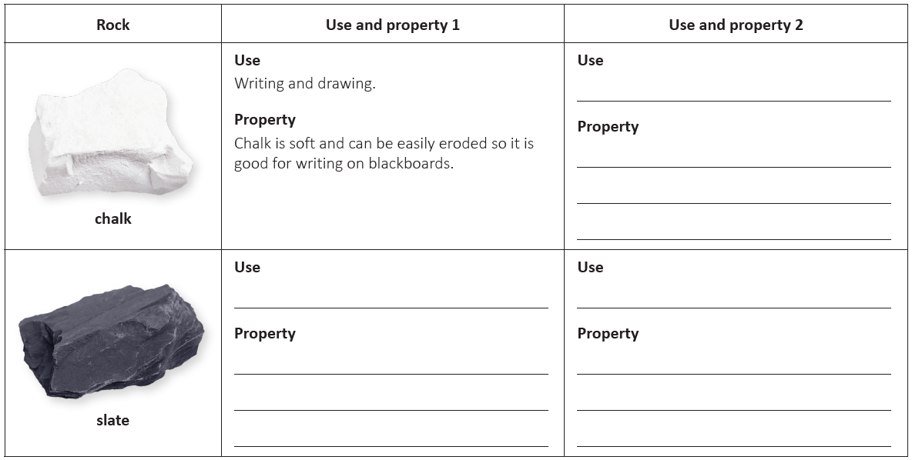
K.O check: What does erode mean? _________________________________________________________________________________
Choose 3 other rocks from the presentation and explain 2 uses for that rock, and what property makes it good for that use.


