
Monday 1st February
L.O: To understand what an Earthquake is and how it is caused
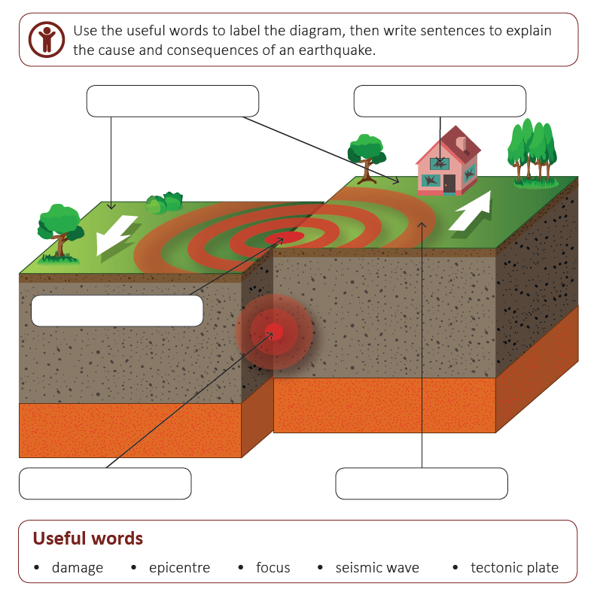
I know how to explain the physical processes that cause earthquakes and volcanic eruptions

Now, use the words above to help you describe how an Earthquake is caused.

