Positive thinking diary
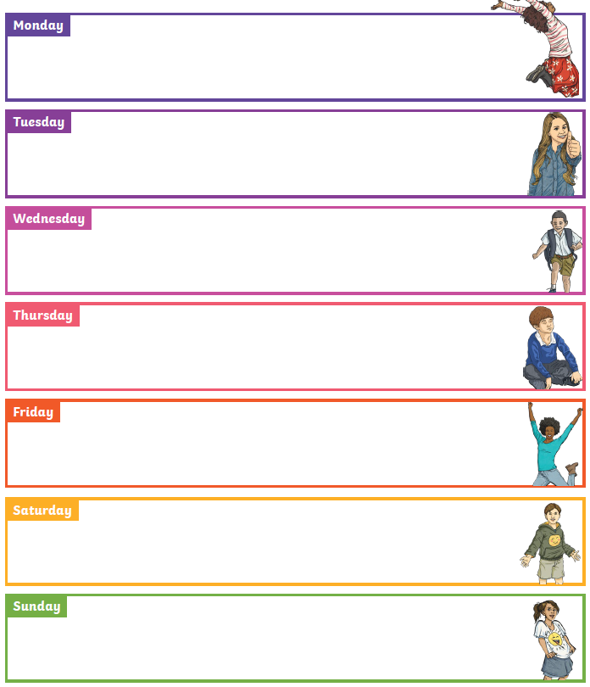
For the next week, think of something positive that has happened each day or something you have done and write it in the box.

