
Wednesday 20th January
L.O: To understand latitude and longitude and use this to locate a volcano on a map
I know how to name and locate significant volcanoes and plate boundaries and explain why they are important.
I know how to locate significant places using latitude and longitude. K.O check: Name a type of volcano ___________________________
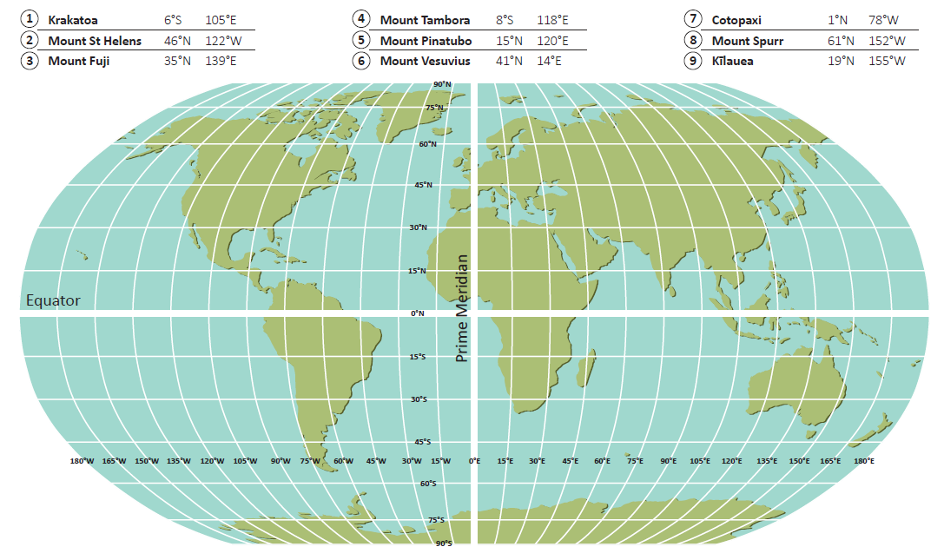
Use the latitude and longitude coordinate to locate these volcanoes on the world map

