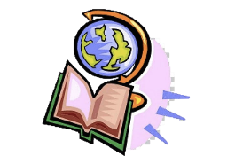
Monday 18th January
L.O: To understand plate tectonics
I know how to describe the activity of plate tectonics and how this has changed the Earth’s surface over time (continental drift)

Use the pictures and words below to describe how the movement of tectonic plates have changed the Earth’s crust over time
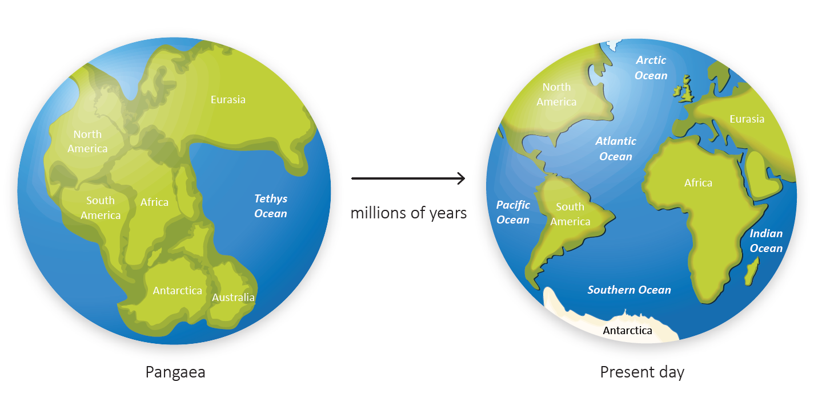
continent, continental drift, joined, Pangaea, supercontinent, tectonic plate

Match the picture to the definition
When two tectonic plates slide against each other and causes earthquakes at the pate boundaries. Major earthquakes can happen by pressure building up if the plates get stuck as they slide.
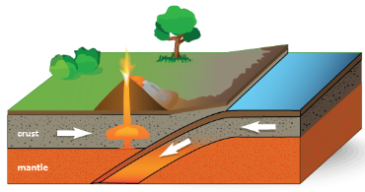
Convergent plate boundary

When two tectonic plates pull apart and forms a gap in the Earth’s crust that is filled with rising magma from the Earth’s mantle. Over millions of years, mountains and volcanoes form along the gap.
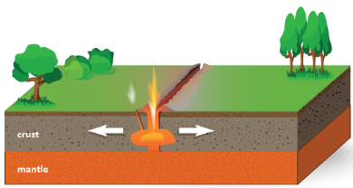
Divergent plate boundary

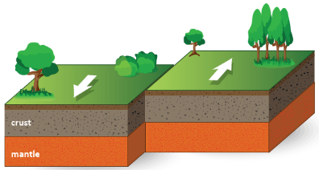
Transform plate boundary
When two tectonic plates push together and the Earth’s crust crumples and buckles. This can form mountain ranges or magma may be released as lava in a volcanic eruption.

