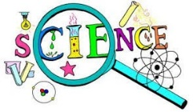
Monday 29th March
L.O: To understand that solids have different melting points
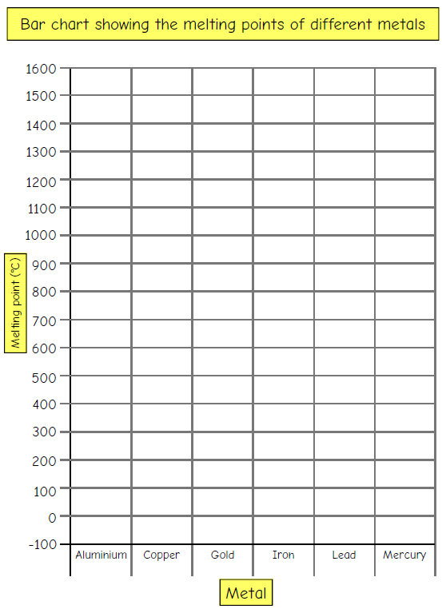
I know that some materials change state when they are heated or cooled and have researched the temperature at when this happens

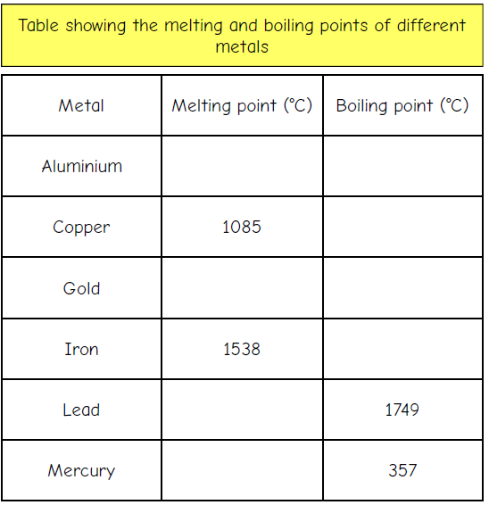
Complete the table below using the internet to help, then use the information to complete the bar chart

NOW: Which metal has the highest boiling point? _____________________

