  Monday 29th March/ Tuesday 30th March  L.O: To observe that some materials change state  I know how to make careful observations and take appropriate measurements |  | Scientific Vocabulary:  Diffusion  Evaporate  Gas  Liquid | Heat  Melt  Scent  Solid
Investigation:  How do smells get up your nose? | Results:  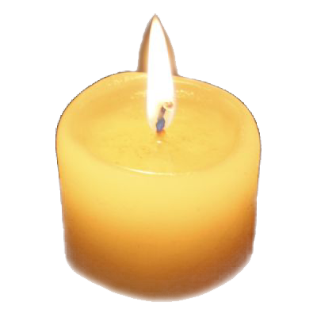  Diagram showing circles around the candle where children are sat. 1 shows the first person to smell, 2 second etc. | Prediction:  Conclusion:
  Time of first person smelling the candle in circle at 1m
  Time of first person smelling the candle in circle at 2m
  Time of first person smelling the candle in circle at 5m
Method:
A scented candle is lit in the middle of the hall. The children are sat still in circles around the candle, the circles are 1m, 2m and 5m away from the candle. A timer is set, and the children put their hand up when they can smell the scent of the candle. The time and location of the child with their hand up is recorded. The test is repeated the folowing day, this time, the adults in the room walk in and out of the circles.
Fair Test:

